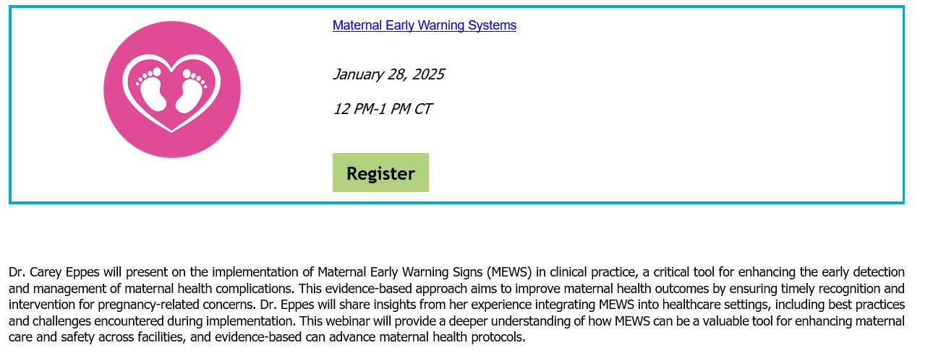

This is the link for registration
https://urlisolation.com/browser?clickId=D09D3A16-4E33-4350-A8D7-19D4D88A542D&traceToken=1737131727%3Bchildrensmed_hosted%3Bhttps%3A%2Figysuzeab.cc.rs6.net%2Ftn.j&url=https%3A%2F%2Fregister.gotowebinar.com%2Fregister%2F8592736591385168986

