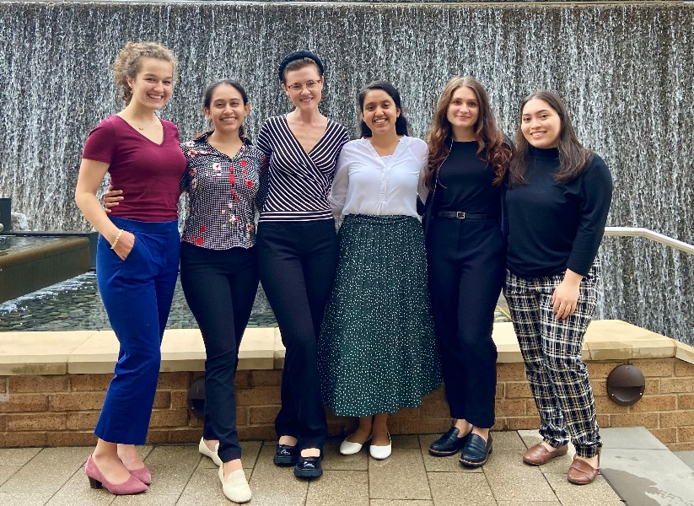We are excited about your interest in the Texas Health Presbyterian Hospital Dallas’s Dietetic Internship Program. Texas Health Presbyterian Hospital is one of 29 acute care hospitals owned, operated or affiliated with Texas Health Resources. Texas Health Resources is one of the largest faith-based, nonprofit health systems in the United States. Since its inception in 1972, our dietetic internship has provided an optimal learning environment and diverse training experiences to prepare our interns to become leaders in the dietetics community.

In-depth program details are included in this packet. After reviewing the material, please feel free to contact me. I look forward to your email.

Sincerely,

Bielca Soza, MS, RD, LD  
Clinical Nutrition Manager and Dietetic Internship Director  
Texas Health Dallas  
[bielcasoza@texashealth.org](mailto:bielcasoza@texashealth.org)

**Open House Sessions**

To schedule a session, email Bielca Soza at [bielcasoza@texashealth.org](mailto:bielcasoza@texashealth.org) and please specify the date in the subject line.

**Virtual Dates:**

December 17, 2024, 2 P.M.

January 7, 2025, 10 A.M.

**In Person Tour Dates:**

December 19, 2024, 10 A.M.

January 14, 2025, 2:30 P.M.

**Registration:**

**Virtual sessions are scheduled as Microsoft Teams meetings. After contacting the internship director, a confirmation email containing the meeting details will be provided.**

**Accreditation**

The Texas Health Dallas Dietetic Internship Program is accredited by the Accreditation Council for Education in Nutrition and Dietetics (ACEND), 120 South Riverside Plaza, Suite 2190, Chicago, IL 60606-6995. Telephone: 800/877-1600, ext. 5400. [www.eatright.org/acend](http://www.eatright.org/acend) Email: [ACEND@eatright.org](mailto:ACEND@eatright.org)

**About the Dietetic Internship Program**

Texas Health Presbyterian Hospital Dallas’s Dietetic Internship Program prepares individuals for entry-level practice and success in future roles in the dietetics profession. This responsibility is accomplished through educational competencies, lectures and supervised practice reflective of the Standards of Education from [ACEND](https://www.eatrightpro.org/acend). The Texas Health Dallas Dietetic Internship is a non-degree program that provides supervised practice to individuals who have earned a Master’s degree or are completing one. This non-degree option includes supervised practice to meet the required competencies of ACEND for dietetic internship programs.

**Dietetic Internship Program Overview**

* Challenging 9-month Non-Degree Program
* Clinical/Medical Nutrition Therapy concentration with strong foodservice curriculum
* Begins September 8, 2025 and ends in early May
* 6 interns accepted
* Interns notified of acceptance in March
* Tuition: $4,800
* Meal Allowance: $10 per day
* Work Schedule: minimum 40-hour work week
* Holidays: Thanksgiving, Christmas, New Years, Spring Break

**Program Completion**

Interns are eligible to complete the program when all rotations and educational competencies have been satisfactorily met per competency requirements from ACEND. If an intern is weak or deemed incompetent in an area, additional learning experiences are planned. These experiences may include repeating a rotation. Program completion is expected by the end of the nine-month program with completion of a minimum of 1072 supervised practice hours. The maximum timeframe allowed to complete the Dietetic Internship Program is 13 months (150% of the program completion timeframe).

After completing the dietetic internship at Texas Health Presbyterian Hospital Dallas, the intern should be well-prepared to take the Registered Dietitian Nutritionist (RDN) exam and function as an entry-level registered dietitian.

All interns in the process of completing a graduate degree will be required to obtain their degree within 12 months of completing the Texas Health Presbyterian DI program. At the successful completion of the dietetic internship program and completion of a graduate degree, individuals will receive their dietetic internship verification statement. Graduates are then eligible to take the registered dietitian exam. The program director will submit data to the Commission on Dietetic Registration, for registration eligibility for students to take the Registration Examination for Dietitians.

**Program Mission**

The mission of Texas Health Presbyterian Hospital Dallas’s Dietetic Internship Program is to provide the intern the opportunity to learn in a continuous process and develop the skills necessary to become a competent entry-level registered dietitian to improve the health of the people in the communities we serve.

**Program Goals**

### The Texas Health Dallas Dietetic Internship program has two primary goals and associated outcomes.

### Program outcomes data are available upon request.

Goal #1: To prepare program graduates to be competent entry-level registered dietitian nutritionists. This is measured by the following standards:

* At least 80% of program interns complete program requirements within 13.5 months (150% of the program length).
* At least 80% of program graduates take the CDR credentialing exam for dietitian nutritionists within 12 months of program completion.
* When surveyed 9-12 months after employment, at least 80% of employers will rate being “satisfied” to “very satisfied” with graduates’ preparation for entry-level practice.
* The program’s one-year pass rate (graduates who pass the registration exam within one year of first attempt) on the CDR credentialing exam for dietitian nutritionists is at least 80%.
* When surveyed 9-12 months after employment, at least 80% of program graduates will rate themselves as “prepared” to “well prepared” for entry level practice.

Goal #2: To produce leaders who improve the health of the community. This is measured by the following standards:

* Of graduates who seek employment, 80% are employed in nutrition and dietetics or related fields within 12 months of passing the RD exam.
* At least 40% of graduates participate in community service activities after internship program completion voluntarily.
* At least 60% of graduates participate in professional organizations or their events.

**Program Information**

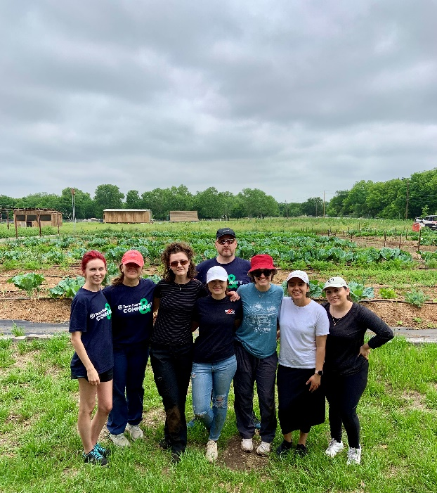Texas Health Presbyterian Hospital Dallas’s Dietetic Internship Program accepts six dietetic interns. Our small class size provides students with more individualized training in all rotations. Our internship program provides training in clinical, food service and community dietetics. Interns will also attend classes taught by dietitians, physicians, respiratory therapists, and other guest speakers to gain advanced knowledge.

The first week is general orientation including hospital orientation, hospital tours, review of policies and procedures, classes and course work. Two additional weeks include clinical orientation. Students will also be given individualized training with the electronic medical record during orientation. This provides students with increased confidence upon entering clinical rotations.

Rotations will begin after orientation. Three students will start clinical rotations, and the other three students will start food service and/or community rotations. At the completion of clinical rotations, each intern will prepare a research-based case study to present to staff and fellow interns. At the end of food service rotations, each intern will prepare an administrative or quality improvement food service project.

**Program Rotations**

The nine-month experience is spent in clinical, food-service-management and community rotations. Rotations increase in difficulty as the year progresses. Interns spend the majority of their rotations at the main Dallas hospital campus under the direction of experienced dietitians. In addition to rotations at Texas Health Dallas, the intern will experience rotations at other locations in the Dallas Metroplex.

**Clinical rotations may include, but are not limited to:**

* Cardiology
* Gastrointestinal Disease
* Medical Surgical
* Neonatology Intensive Care (NICU)
* Neurology
* Nutrition Support – Critical Care
* OB/GYN
* Oncology – Inpatient and Outpatient
* Pediatrics
* Psychiatry
* Rehabilitation
* Trauma
* Wound Care
* Outpatient Diabetes

**Clinical Rotation Sites**

Texas Health Presbyterian Hospital Dallas

[*www.texashealth.org/dallas*](http://www.texashealth.org/dallas)

Texas Health Presbyterian Hospital Plano

[*www.texashealth.org/plano*](http://www.texashealth.org/plano)

Texas Health Harris Methodist Hospital Alliance

[*www.texashealth.org/alliance*](http://www.texashealth.org/alliance)

Texas Scottish Rite Hospital for Children

[*www.tsrhc.org*](http://www.tsrhc.org)

Scottish Rite was established in 1921 and is one of the nation's leaders in pediatric orthopedic conditions. Texas Health Scottish Rite treats children with conditions such as scoliosis, hip disorders, limb length differences, as well as certain related neurological and learning disorders.

University of Texas Health Science Center Pediatric Clinic

[www.unthsc.edu/patient-care/specialties/pediatrics/](http://www.unthsc.edu/patient-care/specialties/pediatrics/)

**Administrative/Food Service**

Administrative and Food Service experiences at Texas Health Dallas provide dietetic interns with many opportunities to have a comprehensive experience of management and administration from supervisors to senior director.

Management rotations occur in a variety of environments including:

* Patient meal services
* Production
* Purchasing
* Café Retail
* Clinical Nutrition Management
* Director and Senior Director Shadow

**Community**

Dietetic interns spend time at various organizations in the Dallas area, learning how an RDN can help improve the health of their communities. These experiences help them develop the cultural competency and skills necessary to provide nutritional education to the public.

**Community Dietetics Rotation Sites**

Visiting Nurse Association - Meals on Wheels

[*Visiting Nurse Association*](http://vnatexas.org/i-need-help/meals-on-wheels?view=page&id=22&task=page.display)

VNA's Meals on Wheels program provides a hot, nutritious, home-delivered midday meal to Dallas County residents who are unable to provide or prepare their own meals due to illness, advanced age or disability.

Texas Health Finley Ewing Cardiovascular and Fitness Center

[*http://www.texashealth.org/dallas-fitness*](http://www.texashealth.org/dallas-fitness)

Interns will be actively involved in nutrition and wellness as they work with exercise physiologists and the dietitian at the fitness center.

Victorem Performance Nutrition

[*https://victorem.com/*](https://victorem.com/)

Victorem Performance Nutrition provides individualized nutrition counseling to endurance athletes. This rotation focuses on the private practice/business aspect of nutrition as well as nutrition related to the athlete.

Lemond Nutrition

[*https://lemondnutrition.com/*](https://lemondnutrition.com/)

Lemond Nutrition is a practice of Registered Dietitians Nutritionists licensed and clinically trained to provide Medical Nutrition Therapy, Diet Counseling, and Nutrition Education for all ages and stages of life.

**Scholarships and Financial Aid**

The[Academy](http://www.adaf.org/) of Nutrition and Dietetics (AND) and state dietetic association such as the Texas Academy of Nutrition and Dietetics (TAND) provide scholarship funds for dietetic interns.  Please refer to their websites for eligibility requirements and application deadlines.

Interns at Texas Health Dallas are not eligible for federally funded student loans. The internship director is available to write letters requesting student-loan deferment during internships.

**Program Calendar**

This general calendar provides an idea of the yearly cycle of the DI program. Interns will have a rotation-driven schedule. On-duty hours will vary based on preceptors and assignments.

|  |  |
| --- | --- |
| Event | Dates (*subject to change) |
| Beginning of the program | September 8, 2025 |
| Thanksgiving holiday | Thursday and Friday of Thanksgiving week |
| Winter Break | 2 weeks over Christmas and New Year |
| Spring Break | 1 week in March |
| Program Completion | Early-Mid May |

**Estimated Internship Expenses**

The following expenses are approximate.

|  |  |  |
| --- | --- | --- |
| Item | Cost | Notes |
| Intern application fee (non-refundable) | $100 | Mail to Director when application is submitted to DICAS |
| Internship Tuition  (non-refundable) | $4,800 | Paid in full by Sept 9, 2025 |
| Apartment | One-bedroom – $1,200 -$1,600 per month | Costs vary; see Housing/Transportation section |
| Utilities | ~$100-200 | This is in addition to rent when it is not included in the lease. |
| Scrubs and non-skid shoes | $150 | *Professional dress cost is not included. Cost will vary. |
| Books | $200-300 | For required texts not already purchased |
| Health insurance (required) | ~$1,500 | Cost may vary. Proof of health insurance is required for program entry. |
| Required vaccinations (Flu) | $30-50 | Cost may vary. |
| Professional fees | $200-$300 | Academy of Nutrition and Dietetics membership, registration for education events |
| Study guide for RD exam | $60-$400 | Various study guides available |
| RD Exam | $225 | Registration for exam *when program is complete.* |
| Liability Insurance | Varies, $30-$50 | Professional liability insurance |
| *Other personal expenses to be mindful of include car maintenance, car insurance, gas and food.*  *\*Expenses are estimates only.* | | |

**PERSONAL REQUIREMENTS**

**Health**

High energy level is essential for keeping up with the rigor of classwork and facility training. Interns provide an example of health to others and serve as role models for the dietetic profession. The hospital’s Employee Health Service provides limited services, but all medical care is the responsibility of interns. Medical insurance is necessary. Extended illnesses may require the extension of rotations beyond the announced program completion date. Missed objectives require additional make-up hours.

**Professional Dress**Interns are always expected to maintain a professional standard of dress and conform to the established dress code during the rotations. Dress codes are clarified for each rotation. Interns must wear business-style clothing at our facilities due to a strictly enforced dress code. Scrubs and slip-resistant shoes are required for the foodservice rotation. Sturdy closed-toe shoes are always required for health and safety reasons. Flat shoes are required for all rotations.

**Working during the Internship**  
Due to the intensity of the dietetic internship program, outside employment is not encouraged. If a student decides to hold a job during the internship, it must not conflict or affect the effort needed to complete the internship. Work schedule needs to be flexible. Outside employment should not infringe on the intern's ability to excel in the program. The intern should be rested, prompt and be prepared for intern experience.

**Housing/Transportation**  
Interns are responsible for their own living arrangements and expenses. Many options are available for housing near the hospital. Information about apartments in Dallas can be found through a search for "Dallas apartments" and "75231" (the hospital ZIP code) and will yield many websites to match search criteria. Upon entering the program, interns wishing to room with another intern can be put in contact with each other.

Interns should have access to dependable transportation to complete rotations. A car is required. Transportation to external facilities is the responsibility of the interns. Many facilities are not accessible by public transportation ([Dallas Area Rapid Transit](http://www.dart.org/) (DART)). Interns may use public transportation for some rotations to avoid traffic congestion and parking limitations, but several rotations sites cannot be reached without a personal vehicle. Free parking is available at several hospitals, but any other parking fees are the responsibility of the intern.

**Health Insurance Options**

Health insurance through Texas Health Dallas is not available to interns. It is the responsibility of interns to obtain their own health insurance.Options include the following:

* The Patient Protection and Affordable Care Act extends health-care coverage to young adults under their parents’ health care plan through age 26. Young adults are eligible for this coverage regardless of any, or a combination of any, of the following factors: financial dependency, residency with parent, student status, employment status and marital status.
* Private or group health insurance
* Extended coverage through a college or university
* Coverage through TWU (if enrolled for graduate credit)

**APPLICATION PROCESS**

Texas Health Presbyterian Dietetic Internship participates in the Dietetic Internship Centralized Application Service (DICAS). The DICAS portal may be accessed at [DICAS](https://urldefense.com/v3/__https:/nam10.safelinks.protection.outlook.com/?url=http*3A*2F*2Fdicas.liaisoncas.com*2F&data=05*7C01*7CLBozich*40eatright.org*7Ce1c20ef177d94931bf9f08da9b4f8641*7C5da1b5c430044586b7ab2dd01f24d7d2*7C0*7C0*7C637993063147128862*7CUnknown*7CTWFpbGZsb3d8eyJWIjoiMC4wLjAwMDAiLCJQIjoiV2luMzIiLCJBTiI6Ik1haWwiLCJXVCI6Mn0*3D*7C3000*7C*7C*7C&sdata=FQ2Ky5hwnF0QMg5tTq*2F4IwyKeFZDfu*2FkTq6U*2FALVeF8*3D&reserved=0__;JSUlJSUlJSUlJSUlJSUlJSUlJSUlJSU!!GT5ojgA9!gG6XvxhAEJbQJOf9oek8aoSHB5jDfRtsZZfPWOkaArBI1I4QLbbCWrn_vk_R4DHXbCQCtff9_6vwcD0NtTRcvd4$). Complete the web application according to DICAS instructions by designated deadline. If you have additional questions regarding the online application process, email [DICASinfo@DICAS.org](mailto:DICASinfo@DICAS.org) or call customer support at 617-612-2855. More information may be found on ACEND’s website at [ACEND](https://www.eatrightpro.org/acend/students-and-advancing-education/application-process-for-students).

The fee to use DICAS is $50 for the first DI program application and $25 for each additional DI program application.

**Admission Requirements**

* Application deadline is February 15, 2025.
* Apply through DICAS portal beginning Monday, August 5, 2024.
* Submission of Supplemental Internship Application Form, $100 non-refundable application fee, professional handwritten letter (see last pages of packet). Must be postmarked no later than February 15, 2025.
  + Mail Supplemental Internship Application Form, handwritten letter and application fee to:

Texas Health Presbyterian Hospital Dallas

Dietetic Internship Program/Food and Nutrition Services

Bielca Soza MS, RD, LD  
8200 Walnut Hill Lane  
Dallas, TX 75231

* Verification Statement of Completion of ACEND accredited Didactic Program requirements.
* Graduate Degree:
  + Master’s degree and completion of an ACEND approved Didactic Program by program start date.

OR

* + Students completing a Master’s must provide proof of enrollment in a graduate program. Provide a degree plan demonstrating how you plan to meet the expected graduation date within 12 months of completing the DI program.
* Declaration of Intent to Complete Academic Requirements *if applicable*.
* Minimum overall GPA 3.0; science GPA 2.75; DPD GPA 3.3 (All based on 4.0 system) in undergraduate coursework.
* Official transcripts from colleges and universities attended.
* Three recommendation letters: 2 professors and at least 1 current or recent employer.
* Personal statement (1,000 words or less). Applicants should submit a personal statement of 1,000 words or less through DICAS and address the following:
  + Why do you want to enter the dietetics profession?
  + Discuss experiences that have helped to prepare you for your career.
  + What are your short-term and long-term goals?
  + What are your strengths and weaknesses (or areas needing improvement)?
* Work experience in foodservice, hospital, nutrition-related field and/or customer service.
* Video interview for selected applicants– *student will receive email with time frame for interview.*

Final acceptance is contingent on background check, drug screen and physical including vaccine records.

**Sending Transcripts**

Review DICAS website for detailed instructions to ensure transcripts are properly matched to application. Send transcripts by mail to the following address:

DICAS Transcript Processing Center  
P.O. Box 9118  
Watertown, MA 02471

**Sending Transcripts Electronically**

DICAS only accepts transcripts from Credentials Solutions and Parchment. If service is not available, transcripts must be sent by mail.

When completing the application form, enter the names and contact information of each of your three references. The Texas Health Presbyterian Dallas Dietetic Internship requires two professor references and one employer reference.

**Texas Health Dallas Supplemental Application & Fee**

Texas Health Presbyterian application fee of $100.00 should be mailed with the Supplemental Internship Application Form and handwritten professional letter. The Supplemental Application is located on the last pages of this information packet. The professional letter should be clear and professional.

The application must be mailed directly to the Texas Health Dallas Internship Program and postmarked no later than February 15, 2025. The ($100) application fee is a separate fee from DICAS.

**Regular Admission Phase:**

Between February 15 – March 15, 2025 applicants will receive a notification of an offer to the program. Applicants who receive an offer of acceptance are responsible for accepting or rejecting the offer by email by April 1, 2025. Applicants who submitted a Declaration of Intent to complete forms with their applications must obtain signed DPD Verification Statements from their DPD program directors and official transcripts documenting completion of their bachelor's degrees prior to beginning dietetic internships.

**Accepted Applicants:**

Applicants will contact the program director by the April 1, 2025 applicant decision date.

Contact information:

Bielca Soza MS, RD, LD  
Office phone: 214-345-7558  
Email: [Bielcasoza@texashealth.org](mailto:Bielcasoza@texashealth.org)

Please e-mail your confirmation and include a contact number to the director.

All accepted applicants must successfully pass a background check and a drug screening prior to program entry.

*Texas Health Dallas is an equal-opportunity institution with regard to employment and admission.*



**Supplemental Internship Application Form**

|  |  |  |
| --- | --- | --- |
|  |  |  |
| Name |  |  |
|  |  |  |
| Telephone Number |  | Email |
|  | | |
| Current Address | | |

|  |  |  |  |  |
| --- | --- | --- | --- | --- |
|  |  |  |  |  |
| City |  | State |  | ZIP Code |

|  |
| --- |
|  |
| Permanent Address |

|  |  |  |  |  |
| --- | --- | --- | --- | --- |
|  |  |  |  |  |
| City |  | State |  | ZIP Code |

|  |  |  |
| --- | --- | --- |
|  |  |  |
| Degree Name |  |  |
|  |  |  |
| Month/Year DPD Coursework Complete |  | Master’s Completion Date (Or expected) |
| Yes No |  | Yes No |
| Degree includes supervised practice credit |  | Master’s includes Thesis |

* + Please include $100 application fee when sending the Supplemental Application Form and handwritten letter. Make money order or cashier’s check payable to Texas Health Presbyterian Hospital.
  + Include a 1–2-page professional handwritten letter and include the following:
    - Describe your interest in Texas Health Presbyterian Dietetic Internship and why you would be a good fit for our program.
    - Describe a time you had to cope with a stressful situation.
    - Describe a situation where you had to apply critical thinking and describe the outcome.
  + Students completing a Master’s are required to include a graduate degree plan to meet the expected graduation date within 12 months of completing the DI program.
    - Edit and include the provided example (on the last page) with your Supplemental Application Form.
  + Supplemental Internship Application Form and letter must be postmarked by February 15, 2025.

Mail Supplemental Internship Application Form, handwritten letter, and application fee to:Texas Health Presbyterian Hospital Dallas

Dietetic Internship Program/Food and Nutrition Services

Bielca Soza MS, RD, LD  
8200 Walnut Hill Lane  
Dallas, TX 75231

**Master’s Degree Plan**

**1. Create your degree plan on a Word or Excel document.**

Demonstrate your plan for completing your Master’s degree by May 2027.

**2. Review Degree Requirements**:

Check your university’s catalog or website for your major’s specific course and credit requirements.

**3. List Completed and Current Courses:**

Include all the courses you have completed or are taking towards your degree plan.

**4. List Required Courses:**

Write down all the courses you still need to complete based on your degree plan, including prerequisites.

**5. Plan Your Semesters:**

Distribute your remaining courses across future semesters.

* Below is a degree plan example for a dietetic intern for the 2025-2026 dietetic internship program year.
* The internship begins in fall 2025 and ends in late spring 2026. In the example, their graduate degree allows for supervised practice credit.
* The intern is required to attain their graduate degree and take the Registration Examination for Dietitians within 12 months of completing the Texas Health Presbyterian Dietetic Internship program.

|  |  |  |  |  |  |  |  |  |
| --- | --- | --- | --- | --- | --- | --- | --- | --- |
|  | Master of Science (example) | | | | | |  |  |
|  | **Major: Nutrition** | |  |  |  |  |  |  |
|  | Name: |  |  |  | College: |  |  |  |
|  | Total Credit Hours: 36 | |  |  | Expected Graduation Date: Fall 2026 | | | |
|  | Total Completed Hours: 12 | | |  | Thesis or Non-Thesis: | | | |

|  |  |  |  |  |  |  |  |  |  |  |  |  |  |  |  |  |
| --- | --- | --- | --- | --- | --- | --- | --- | --- | --- | --- | --- | --- | --- | --- | --- | --- |
| Ex: Spring | 2025 |  |  |  |  |  |  |  | Ex: Fall | 2025 |  |  |  |  |  |  |
| Semester 1 (Fall or Spring) | | | | | | | CRD |  | Semester 2 (Fall or Spring) | | | | | | | CRD |
| NFS 5200 | Human Diseases | | | | | | 3 |  | NFS 5500 | Exercise Physiology | | | | | | 3 |
| NFS 5650 | Public Health | | | | | | 3 |  | NFS 5900 | Supervised Practice Credit | | | | | | 3 |
| NFS 5400 | Biochemistry | | | | | | 3 |  | Semester Credits | | | | | | | 9 |
| MATH 5500 | Statistics |  |  |  |  |  | 3 |  |  |  |  |  |  |  |  |  |
| Semester Credits | | | | | | | 12 |  |  |  |  |  |  |  |  |  |
|  |  |  |  |  |  |  |  |  | Ex: Fall | 2026 |  |  |  |  |  |  |
| Ex: Spring | 2026 |  |  |  |  |  |  |  | Semester 4 (Fall or Spring) | | | | | | | CRD |
| Semester 3 (Fall or Spring) | | | | | | | CRD |  | NFS 5700 | Research Methods | | | | | | 3 |
| NFS 5900 | Supervised Practice Credit | | | | | | 3 |  | NFS 5600 | Food & Drug Interactions | | | | | | 3 |
| NFS 5900 | Supervised Practice Credit | | | | | | 3 |  | NFS 5450 | Seminar | | | | | | 3 |
| Semester Credits | | | | | | | 6 |  | Semester Credits | | | | | | | 9 |